**A Secure Data Dynamics and Public Auditing Scheme for Cloud Storage**

**OBJECTIVE:**

This paper desire to suggest a secure public auditing scheme applying third party auditors to authenticate the privacy, reliability, and integrity of data stored in the cloud. This proposed auditing scheme composes the use of the **AES-256 algorithm** for encryption. And perform data dynamics operation which deals with mostly insertion, deletion, and, modification.

**ABSTRACT:**

Cloud computing is an evolving technology that provides data storage and highly fast computing services at a very low cost. All data stored in the cloud is handled by their cloud service providers or the caretaker of the cloud. The data owner is concerned about the authenticity and reliability of the data stored in the cloud as the data owners. Data can be misappropriated or altered by any unauthorized user or person. This paper desire to suggest a secure public auditing scheme applying third party auditors to authenticate the privacy, reliability, and integrity of data stored in the cloud. This proposed auditing scheme composes the use of the AES-256 algorithm for encryption, SHA-512 for integrity check and RSA-15360 for publickey encryption. And perform data dynamics operation which deals with mostly insertion, deletion, and, modification.

**EXISTING METHOD**

All data stored in the cloud is handled by their cloud service providers or the caretaker of the cloud. The data owner is concerned about the authenticity and reliability of the data stored in the cloud as the data owners. Data can be misappropriated or altered by any unauthorized user or person.

**PROPOSED METHOD**

This proposed auditing scheme composes the use of the AES-256 algorithm for encryption, SHA-512 for integrity check and RSA-15360 for publickey encryption. And perform data dynamics operation which deals with mostly insertion, deletion, and, modification.

**BLOCK DIAGRAM:**

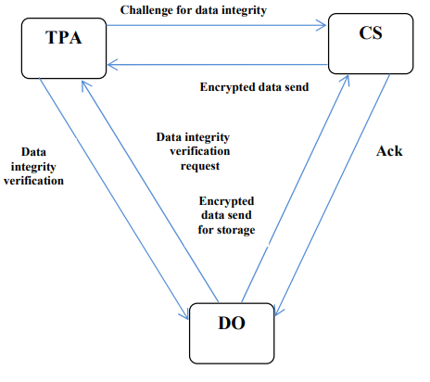

**ADVANTAGES**

* Improving Data Privacy
* Providing more Security to the Data
* High efficiency
* Confidentiality and privacy

**APPLICATIONS**

1. Software Industries.
2. Startup Companies.